Permanently open door doesn’t activate alarm

Description:

In standard scenario you swipe a card and the door stays open for some specific time. If you want the door to be open for a longer time (until you close it again) you can do it by holding card longer time for a few seconds. With the same action, you close the door again so that it opens normally.

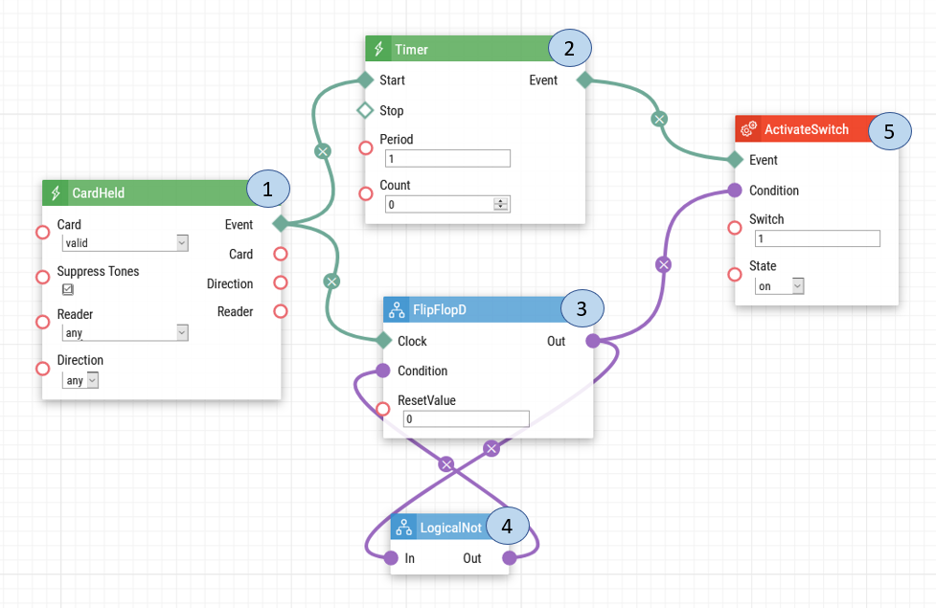
- Card Held. When a valid card is held to the RFID card reader, a signal is sent to Timer and Flip Flop D.
- Timer. The Timer determiners how long the card should be held at the card reader for the switch to be activated.
- Flip Flop D. When the signal is received from the Card Held, it will send that signal to Logical Not, to receive the reversed version of the signal. Once the Flip Flop D has receives the reversed signal it will send out the new signal to Activate Switch.
- Logical Not. The Logical Not will change the value of the signal by reversing it from 1 to 0 or 0 to 1. The reverse signal value will be sent to Flip Flop D.
- Activate Switch. Once the switch is activated it will be permanently open and then when the card is held to the reader a second time, the switch will return to its normal state.

Note: For the automation to work, the Door Open Too Long Detection must be enabled and door contact must be connected.

Intercom Door Configuration:
If you have previously configured the door open too long setting please follow the steps below.

1: Upon login select the Hardware option.
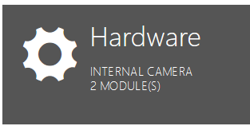
2: From the left-hand menu select Door.
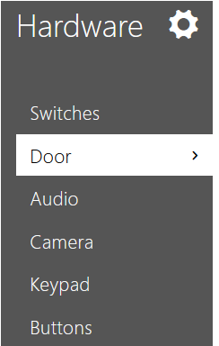

3: On the Door tab, enable the Door Open Too Long Detection. You are also able to adjust the time limit of the Door Open Time. Once you are finishing choosing the settings, click Save.
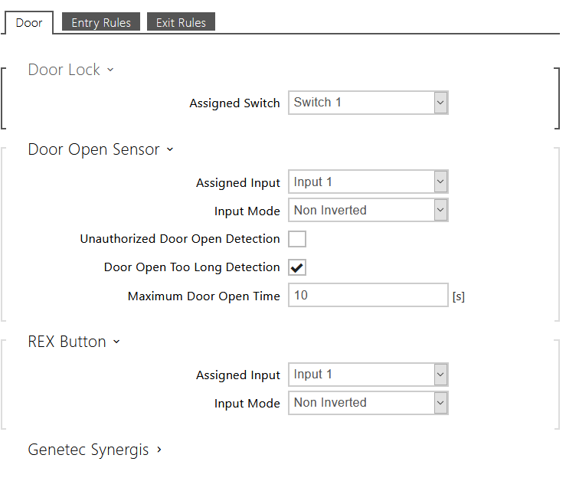

Date of automation design: 07/17/2020

Firmware Version: 2.29.1.38.8

List of compatible Hardware:
- 2N IP Verso with RFID
- 2N IP Vario with RFID
- 2N IP Base with RFID
- 2N IP Force with RFID
- 2N LTE Verso RFID
- 2N Access Unit 2.0 with RFID
- 2N Access Unit with RFID

List of adjustable user credentials:
- Users
- Cards
- Fobs
List of Automation Parameters:
- Card
- Reader
- Direction
- Period
- Count
- Reset Value
- Switch
- State

Requirements:
- 2N Intercom with RFID
- Door contact
- 2N Enhanced Integration license (or Gold license) *Not applicable to the USA

