One-off code for visitors

Description:
One-off code on the keypad. You can use a web browser on your PC or mobile phone to define codes for guests using HTTP commands. When an HTTP command is received, the code is set to one time access. Once the code is entered, the Switch is activated and the condition reverts back to False = the code doesn't work anymore. You can set up to 25 guest codes (6*5*5 objects)
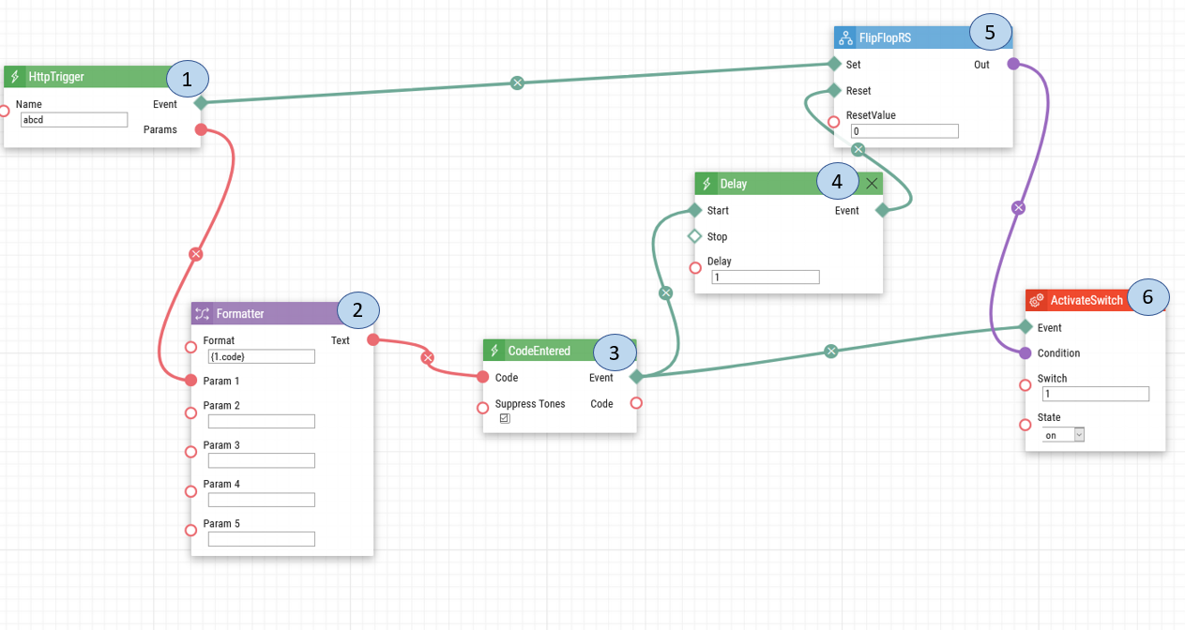
- HTTP Trigger. An HTTP API command which holds the code is sent to both the Flip Flop RS and the Formatter.
- Formatter. The formatter converts the HTTP API command into a text format to be sent to the Code Entered.
- Code Entered. Once the user enters the code at the intercom's keypad, a signal is sent to both the Delay and Active Switch.
- Delay. The delay is set for one second to ensure that the code is being entered rather than contact is dialled.
- Flip Flop RS. After the delay, if the code entered at the intercom matches the code from the HTTP API command, a signal is sent to Activate Switch.
- Activate Switch. Once the Flip Flop RS sends the signal that the codes match, the switch is activated, and the door will be unlocked.

Note: This automation works by sending an HTTP API command via the computer with a one-time code that is to be entered on the IP Intercom.

Date of automation design: 07/17/2020

Firmware Version: 2.29.1.38.8

List of compatible Hardware:
- 2N IP Verso with touch display, keypad, touch keypad or combo module with touch keypad
- 2N IP Vario with keypad
- 2N IP Force with keypad
- 2N Access Unit 2.0 with touch display, keypad, touch keypad or combo module with touch keypad
- 2N Access Unit with keypad, touch keypad or combo module with touch keypad

List of adjustable user credentials:
- Users
- User code
- Entry code
- HTTP API commands
List of automation parameters:
- Name
- Format
- Switch
- Delay
- Reset Value
- State

Requirements:
- 2N Intercom with keypad
- 2N Enhanced Integration license (or Gold license) *Not applicable to the USA

