An intercom as a walkie-talkie

Description:
Push to talk, similar to a walkie talkie. Since I am holding the button I can talk. I listen when I release the button.

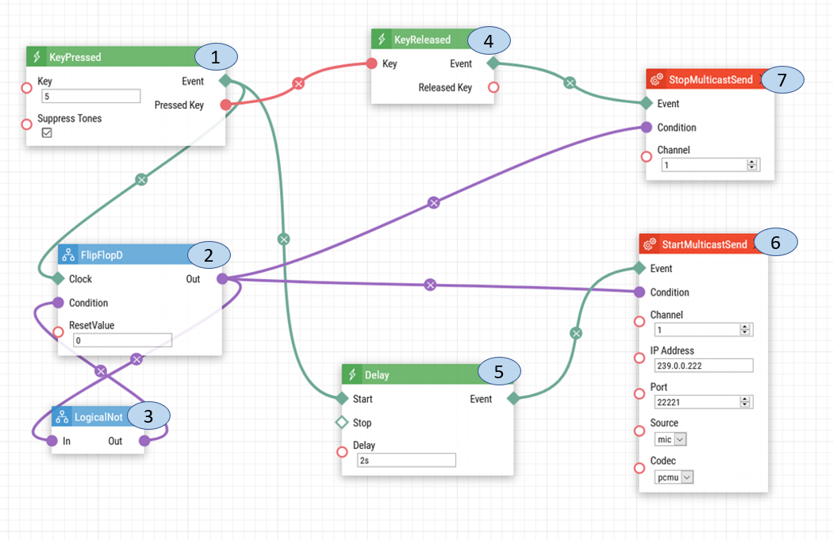
1 - Key Pressed. When the number 5 is pressed on the keypad, a signal is sent to the Delay, Flip Flop D and Key Released.
2 - Flip Flop D. When the signal is received from the Key Pressed, it will send that signal to Logical Not, to receive the reversed version of the signal. Once the Flip Flop D receives the reversed signal it will send out the new signal to Start Multicast Send and Stop Multicast Send.
3 - Logical Not. The Logical Not will change the value of the signal by reversing it from 1 to 0 or 0 to 1. The reverse signal value will be sent to Flip Flop D.
4 – Key Released. The signal starts tranmitting from the key pressed, and the key released will active once the the signal stops from the Key Pressed, afterwards the key released will send a signal to the stop multicast send.
5 - Delay. The signal from the Key Pressed is sent to the delay, to allow time for the multicast channels to open and be ready for broadcasting.
6 - The Start Multicast Send will activate once the number 5 is pressed and will start broadcasting.
7 - The Stop Multicast Send will activate when the number 5 is released and will stop broadcasting.

Intercom Multicast Configuration:
The receiving intercom must also have the Multicast Receiver Enabled. The IP address and port will be based on the multicast settings in your network, please use the following steps to set up the Multicast Receiver.

1: Upon login select the Services option.
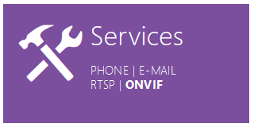

2: On the left-hand menu select Streaming.
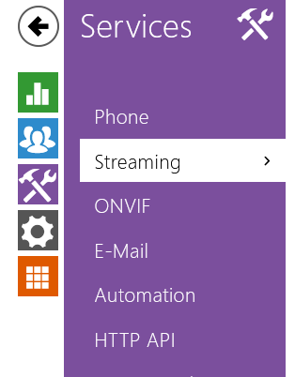
3: Select the Multicast tab
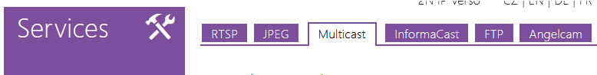
4: Select the Multicast Receiver Enabled and then input the multicast address, port and codec
Use the example below as a guide to setting up the Multicast Receiving networking: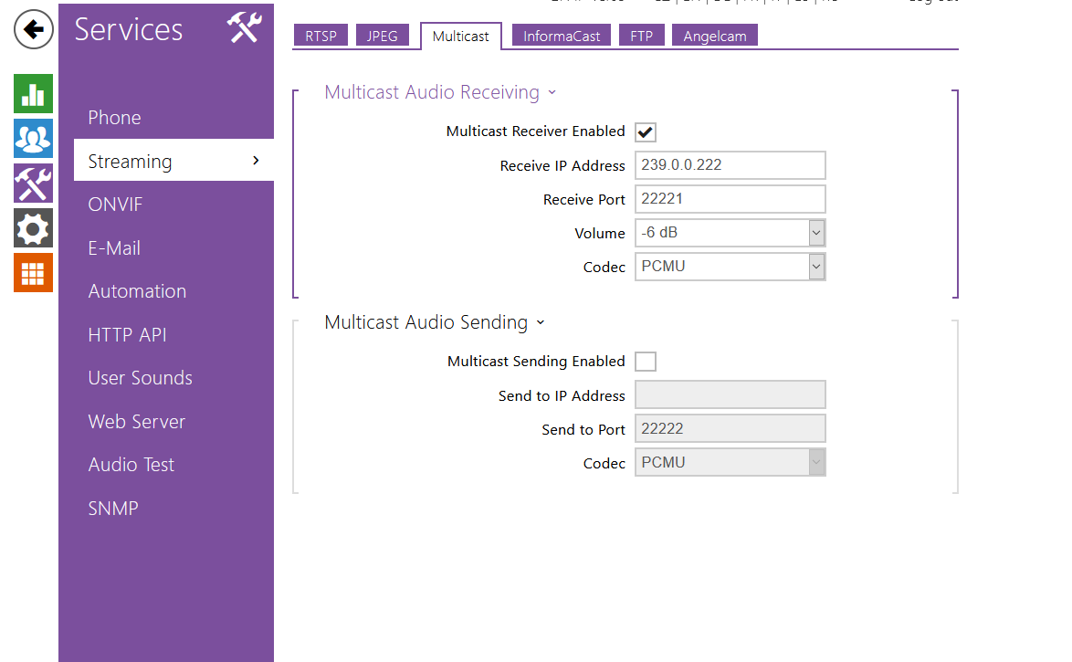

Date of automation design: 07/17/2020

Firmware Version: 2.29.1.38.8

List of compatible Hardware:
- 2N IP Verso
- 2N IP Vario
- 2N IP Force
- 2N IP Safety
- 2N IP Base
- 2N IP Solo

List of automation parameters:
- Key
- Reset Value
- Delay
- Channel
- IP Address
- Port
- Source
- Codec

Requirement:
- 2N IP Intercoms
- 2N Enhanced Integration Licences or Gold Licence. *Not applicable to the USA

